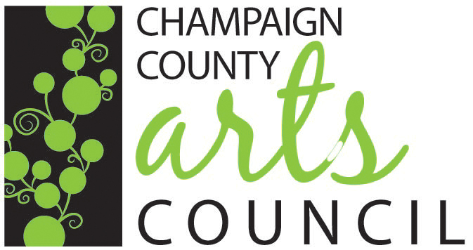
6th ANNUAL
JURIED ART EXHIBITION
2019 CALL FOR ENTRIES

Eligibility
All artwork must be original and submitted by the artist, age 18 or older. Artwork must be current (within the last two years) and can not have been entered in the Arts Council’s previous shows. This exhibit is open to artwork in any medium. Artists need not be a member of the CCAC. The CCAC reserves the right to refuse any entry.

Fee
There is a non-refundable entry fee of $25-$40, depending on the number of entries and whether you are a CCAC member (see registration form). You may join the Arts Council upon entry and receive the member price. Limit of five entries per person. Entry entitles the CCAC to photograph entries for publicity and promotional purposes.

Awards
Awards will be given overall to 1st ($100), 2nd ($75) and 3rd ($50) places, as well as Best of Show ($250).

Sales
Artwork need not be for sale. However, if an item is for sale, it must include any frame, hardware, etc. that is displayed. The CCAC will receive 20% of the sale price from members; 30% from non-members.

Preparation
2-D work must be wired to hang—no saw tooth or triangle loop hooks. Artwork must also be framed, except for canvases where framing is unnecessary. There is no size limit on the artwork.

Submission
Registration forms are due by April 12th and can be dropped off or mailed to the Champaign County Arts Council, 119 Miami Street, Urbana, OH 43078.

Drop-Off
Deliver pre-registered artwork to the CCAC at 119 Miami St. in Urbana on Saturday, April 27th between the hours of 9 a.m. and Noon.

Reception
The awards ceremony will take place during our Annual Celebration of the Arts on Friday, May 3rd from 5-9 p.m. Award winners will receive a complimentary ticket. Additional tickets may be purchased through the Arts Council.

Pick-Up
Artwork should be picked up at CCAC on Saturday, May 18th between the hours of 9 a.m. and Noon.

Liability
The CCAC is not responsible for damage or theft of the entries.

REGISTRATION FORM

Artist Name ___________________________________________________________________________

Address ________________________________________________________________________________

Phone ______________________________ E-Mail ___________________________________________

CCAC Member? (Circle One) Yes No
Sign Me Up! (Circle One) Senior $15 Individual $20 Family $35

Total Entry
Members
$25 flat fee for 3 pieces or $40 for 5 pieces $ ___________
Non-Members
$35 flat fee for 3 pieces or $50 for 5 pieces $ ___________

By signing this form, the artist agrees to the following:
- The Arts Council is not liable for loss of artwork due to fire, vandalism, or theft. The artist must assume liability for any damage occurring to the artwork.
- The Arts Council retains the right of refusal for any work—no explanation needed.

____________________________________________ ______________________________
^{Artist Signature} ^{Date}

Piece #1

Title ___________________________
Price $_________________________
Size ___________________________

Piece #4
Title ___________________________
Price $_________________________
Size ___________________________
Piece #2
Title ___________________________
Price $_________________________
Size __________________________

Piece #5

Title ___________________________
Price $_________________________
Size ___________________________
Piece #3
Title ___________________________
Price $_________________________
Size ___________________________

